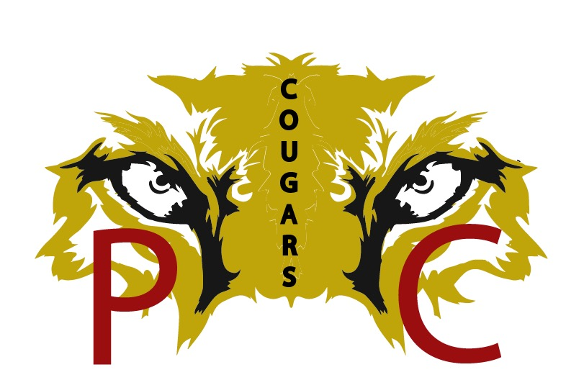
2025
We are projecting an estimated budget of $33,900 that will cover the equipment cost of 120 kids. The itemized breakdown of the cost is as follows:

40 Shoulder Pads = $4,000
40 Helmets = $8,000
60 Practice Jersey = $400
Complete Game Uniforms = $5,200
Mouth Pieces = $100
League fees = $1,000
Officiating fees = $3,200
Insurance = $1,200
Game Day Security / Police/ Certified First Aide Trainer = $1675.00?
Transportation = $5,000?

WE R
PC4LIFE

